

**Automated mop cleaner**

**Jamal Al Hijawi, Omar Abass, Jack Dabour, and Abdullah Zaher**

**Supervisor: Dr. Belal Sababha  
Embedded Systems Final Design Project, Spring 2023   
King Abdullah II School of Engineering**

**Princess Sumaya University for Technology**

**Abstract:**

This report presents the development and evaluation of an Automated Mop Cleaner, a revolutionary device designed to automate and optimize floor cleaning processes. The report provides an overview of the design aspects, including mechanical, electrical, and software components. Additionally, it discusses encountered problems during the development phase and provides recommendations for future improvements. The report concludes with key findings and insights gained from the project.

**Introduction:**

Keeping floors clean is a crucial task in both residential and commercial settings, often requiring significant time and effort. The objective of this project was to design an Automated Mop Cleaner that could effectively and autonomously clean and mop floors, streamlining the cleaning process and enhancing efficiency. By integrating advanced technologies, including obstacle avoidance and customizable scent options, the cleaner aimed to revolutionize the floor cleaning experience.

**Design:**

1. **Body design:**

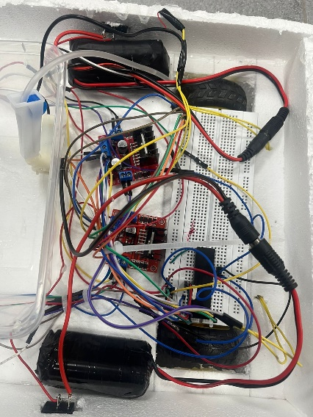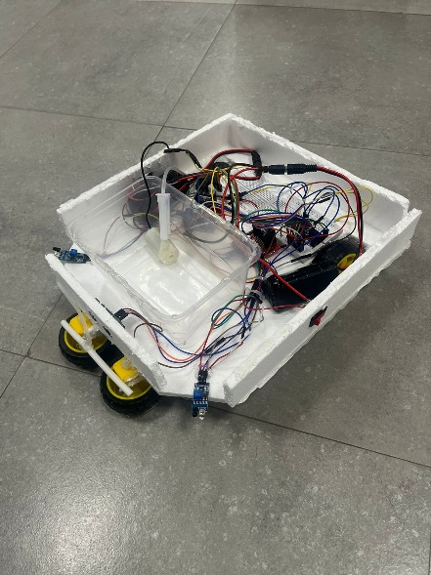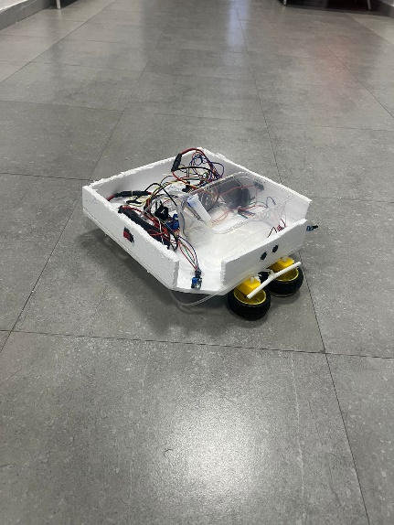

**Figure 1 Mop body**

1. **Electrical design:**

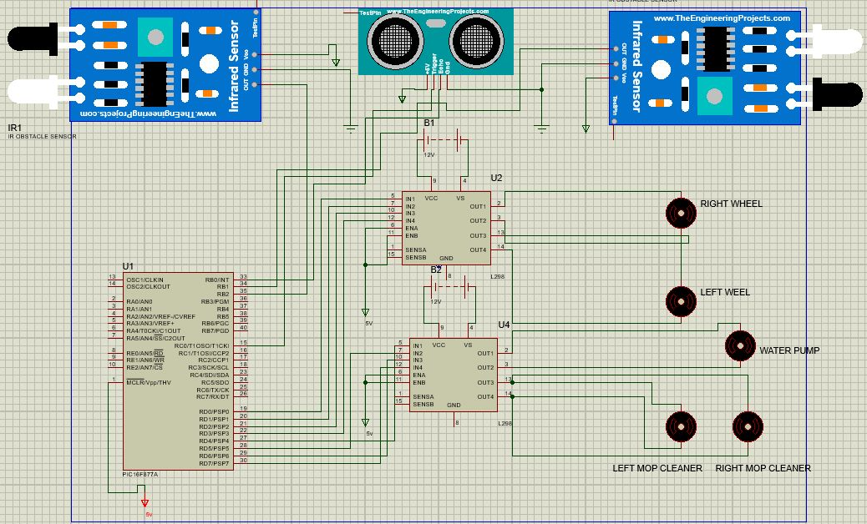

**Figure 2 Electrical schematic of the connected ports with pic 16F877A**

**Flow chart:**

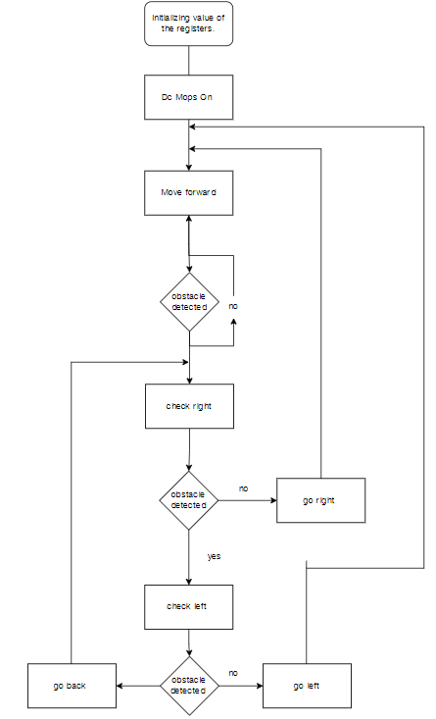

**Figure 3 Flow chart**

**Problems and Recommendations:**

During the development phase, several challenges were encountered. These included occasional navigation errors, suboptimal obstacle detection, and limited customization options. To address these issues, future improvements could focus on refining the navigation algorithms, enhancing obstacle detection capabilities, and expanding the range of scent customization options. Additionally, user-friendly interfaces and intuitive controls could further enhance the user experience.

**Conclusion:**

In conclusion, the development of the Automated Mop Cleaner represents a significant advancement in floor cleaning technology. The integration of mechanical, electrical, and software design elements resulted in an autonomous cleaner capable of delivering exceptional cleaning performance. Despite encountering some challenges, valuable lessons were learned, laying the foundation for future improvements. The project successfully demonstrated the potential for revolutionizing floor cleaning processes, offering time-saving and customizable solutions.